Project Report On

Sorting Visualizer

***- Data Structure and Algorithm site***

**Prepared By**

***Ajit Khanta***

**BCA Sem-6**

**Project Guided**

Sh. Sachin Pandit

Government Post Graduate College Nahan

**District Sirmour (H.P)**

## Submitted To

**Himachal Pradesh University Shimla**



The project report is submitted as a part of the course leading to the Bachelor of Computer Application (BCA) prescribed by **“**HIMACHAL PRADESH UNIVERSITY**”.** It is Very necessary to make project in SEM - VI.

The project work is about Data Structure and Algorithm Visualizer sites like visualgo.com., . My project name is Sorting Visualizer.

Here is the detailed report on the project. I have developed my project using HTML, CSS and JAVASCRIPT.

The objective of this report is to provide both conceptual and understanding of the system as well as working guide.



I would like to express my special thanks of gratitude to my teacher Sh. Sachin Pandit who gave me the golden opportunity to do this wonderful project on the topic Sorting Visualizer which also helped me in doing a lot of Research and I came to know about so many new things.

I am really thankful to them.

Secondly, I would also like to thank my parents and friends who helped me a lot in finishing this project within the limited time.

I am making this project not only for marks but to also increase my knowledge.

THANKS AGAIN TO ALL WHO HELPED ME.

**Thanking you** ….

Yours Faithfully,

***Ajit Khanta***

|  |  |  |
| --- | --- | --- |
| **Sr. No** | **Subject Title** | **Page No** |
| **1** | **Project Profile** | **5** |
| **2** | **Introduction to Front and Back End Tools**   1. *HTML* 2. *CSS* 3. *JavaScript* | **6** |
| **3** | **Project Introduction** | **11** |
| **4** | **Analysis** | **12** |
| **5** | **Feasibility study**   1. *Economic analysis* 2. *Technical feasibility* 3. *Operational feasibility* | **14** |
| **6** | **System design**   1. *Dataflow diagram* 2. *E-R Diagram* | **15** |
| **7** | **Project Management** | **30** |
| **8** | **User interface**   1. *Screen layout* | **31** |
| **9** | **Testing** | **59** |
| **10** | **Deployment** | **60** |
| **11** | **Maintenance** | **61** |
| **12** | **Bibliography** | **62** |





**Project Title:** **Sorting Visualizer**

**Platform:** Windows 7,8,10,11

**Client Side:** Any Network.

**Technology:** JavaScript.

**Front End:** Html, JavaScript, CSS.

**Documentation Tool:** Microsoft Word.

**Period of Project Working:** 3 Months.

**Project Guide:** Sh. Sachin Pandit

**Developed By:** Ajit Khanta.

**Submitted To:** Himachal Pradesh University (Shimla).



What is HTML?

HTML is a language for describing web pages.

* HTML stands for **H**yper **T**ext **M**arkup **L**anguage.
* HTML is a **markup** language.
* A markup language is a set of markup **tags.**
* The tags **describe** document content.
* HTML documents contain HTML **tags** and plain **text.**
* HTML documents are also called **web pages.**

HTML Tags

HTML markup tags are usually called HTML tags

* HTML tags normally **come in pairs** like <b> and </b>
* The first tag in a pair is the **start tag,** the second tag is the **end tag**
* The end tag is written like the start tag, with a **forward slash** before the tag name
* Start and end tags are also called **opening tags** and **closing tags**

HTML Elements

"HTML tags" and "HTML elements" are often used to describe the same thing.

But strictly speaking, an HTML element is everything between the start tag and the end tag, including the tags:

Web Browsers

The purpose of a web browser (such as Google Chrome, Internet Explorer, Firefox, Safari) is to read HTML documents and display them as web pages.

The browser does not display the HTML tags, but uses the tags to determine how the content of the HTML page is to be presented/displayed to the user:

HTML Versions

Since the early days of the web, there have been many versions of HTML:

|  |  |
| --- | --- |
| **ersion** | **Year** |
| HTML | 1991 |
| HTML+ | 1993 |
| HTML 2.0 | 1995 |
| HTML 3.2 | 1997 |
| HTML 4.01 | 1999 |
| XHTML 1.0 | 2000 |
| HTML5 | 2012 |
| XHTML5 | 2013 |

HTML Page Structure

<html>

<body>

<h1>This a heading</h1>

<p>This is a paragraph. </p>

<p>This is another paragraph. </p>

</body>

</html>

 

What is CSS?

* **CSS** stands for **C**ascading **S**tyle **S**heets
* Styles define **how to display** HTML elements
* Styles were added to HTML 4.0 **to solve a problem**
* **External Style Sheets** can save a lot of work
* External Style Sheets are stored in **CSS files**

Styles Solved a Big Problem

HTML was never intended to contain tags for formatting a document. HTML was intended to define the content of a document, like:

<h1>This is a heading</h1>

<p>This is a paragraph. </p>

When tags like <font>, and color attributes were added to the HTML 3.2 specification, it started a nightmare for web developers. Development of large web sites, where fonts and color information were added to every single page, became a long and expensive process.

To solve this problem, the World Wide Web Consortium (W3C) created CSS.

In HTML 4.0, all formatting could be removed from the HTML document, and stored in a separate CSS file.

All browsers support CSS today.

CSS Saves a Lot of Work!

CSS defines HOW HTML elements are to be displayed.

Styles are normally saved in external .CSS files. External style sheets enable you to change the appearance and layout of all the pages in a Web site, just by editing one single file!

CSS Syntax

A CSS rule has two main parts: a selector, and one or more declarations:

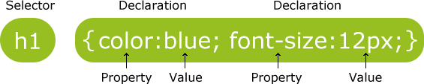

The selector is normally the HTML element you want to style. Each declaration consists of a property and a value.

The property is the style attribute you want to change. Each property has a value.

CSS Example

A CSS declaration always ends with a semicolon, and declaration groups are surrounded by curly brackets:

p {color:red;text-align:center;}

 

What is JavaScript?

A scripting language is a lightweight programming language. JavaScript is programming code that can be inserted into HTML pages.

JavaScript inserted into HTML pages, can be executed by all modern web browsers.

###### Did You Know?



JavaScript and Java are two completely different languages, in both concept and design.

Java (invented by Sun) is a more complex programming language in the same category as C.

ECMA-262 is the official name of the JavaScript standard.

JavaScript wa

s invented by Brendan Eich. It appeared in Netscape (a no longer existing browser) in 1995, and has been adopted by ECMA (a standard association) since 1997.

JavaScripts in HTML must be inserted between <script> and </script> tags.

JavaScripts can be put in the <body> and in the <head> section of an HTML page.

###### The <script> Tag

To insert a JavaScript into an HTML page, use the <script> tag.

The <script> and </script> tells where the JavaScript starts and ends. The lines between the <script> and </script> contain the JavaScript:

 

Sorting Visualizer.com a Data Structure and Algorithm Visualizer sites designed to help users to visualize various Sorting Algorithm. The main goal of the service is to make your understanding better. Sorting Visualizer helps you to understand Sorting concepts and find difference between Time and Space Complexity of various Sorting Algorithm.

The project work is about Data Structure and Algorithm Visualizer sites like visualgo.com., .My project name is Sorting Visualizer.

­

Here is the detailed report on the project. I have developed my project using HTML, CSS and JAVASCRIPT

The project designed is very simple and easy to understand. This project include facility to visualize various types of Sorting algorithms. This project include button for adjustment of **Size** and **Speed** for better experience.



When I started My Project First of all I had seen Top Social Networking Web Sites Like [www.Facebook.com](http://www.Facebook.com/) , [www.](http://www/) Twitter.com , [www.orkut.com](http://www.orkut.com/) etc. And seen their Facility which they provide.

Then i collected the Information about Top Social Networking Web Sites then I collect information which i want for my Website.

I have Seen Facebook’s Create Page Facility and Then I have Created Faceback Social Networking.

I given following facilities in My website.

* + Ajax Search engine
  + Upload image
  + Update status
  + Like
  + Comment
  + Profile
  + Group chat
  + online

System requirement

* **SOFTWARE REQUIREMENT**
  + Windows 7,8,10,11
  + Text Editor (Any of Following)
* Notepad
* Visual Studio Code
  + Web Browser latest version (Any of Following)
* Opera Browser
* Google Chrome
* Mozilla Firefox
  + Microsoft word
* **HARDWARE REQUIREMENT**
  + Pentium –IV Processor 1.5GHz or Above
  + Minimum 80 GB Hard disk
  + Minimum 1GB RAM
  + Mouse, Keyboard
  + 4x CR-ROM drive OR USB port



Feasibility study is a process to check possibilities of system development. It is a method to check various different requirements and availability of financial & technical resources.

Before starting the process various parameters must be checked like estimated finance is there or not? The man power to operate the system is there or not? The man power is trained or not?

All the above conditions must be satisfied to start the project. This is why in depth analysis of feasibility is carried out.

There are three different ways feasibility can be tested:

* Economical Feasibility:

In this Field There is no cost for me Because This the part of Study.

* Technical Feasibility:

Faceback.com Web site is basically used to see existing computer, hardware and software etc., weather it is sufficient or additional equipment’s are required? Minimum System Requirements such that it can be affordable by of the user who is having computer. All the user requires is compatible browser installed so our system is fully technical feasible

* Operational Feasibility:

Once the system is designed there must be trained and expert operator. If there are not trained, they should give training according to the needs of the system. From the user’s perspective our system fully operational feasible as it just requires some knowledge of computer.







SortingVisualizer.com Data Structure and Algorithm Visualizer sites had managed only one sides.

1. Client Side

* **Client side**
  + Add New Array
  + Increase or Decrease Array Size
  + Increase or Decrease Array Sorting speed.
  + Stop Visualization

 

# **User Side**

**Mobile View**

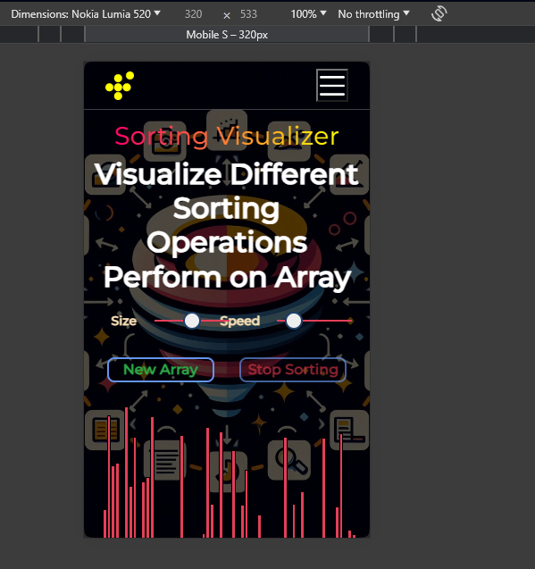

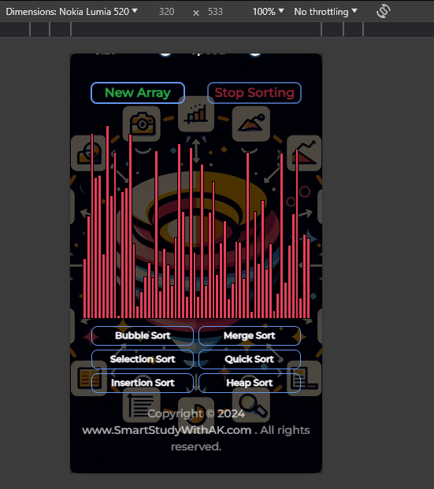

**Tablet View**

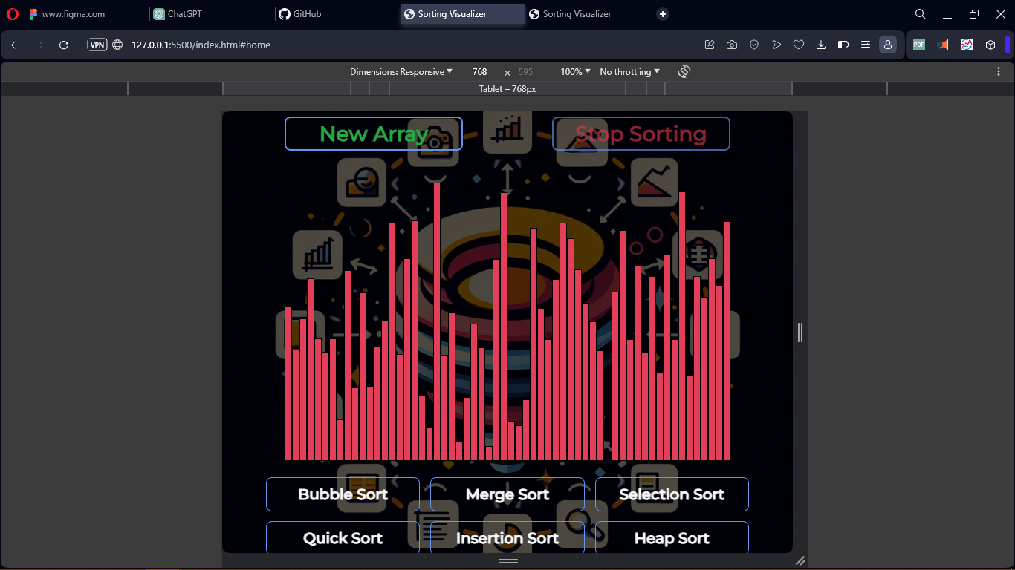

**Desktop View**

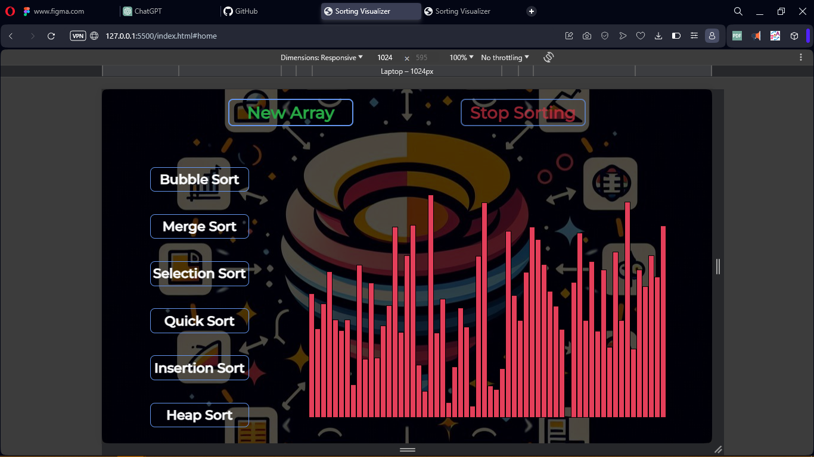



## white box testing

White Box Testing is the testing of a software solution's internal coding and infrastructure. It focuses primarily on strengthening security, the flow of inputs and outputs through the application, and improving design and usability. White box testing is also known as clear, open, structural, and glass box testing.

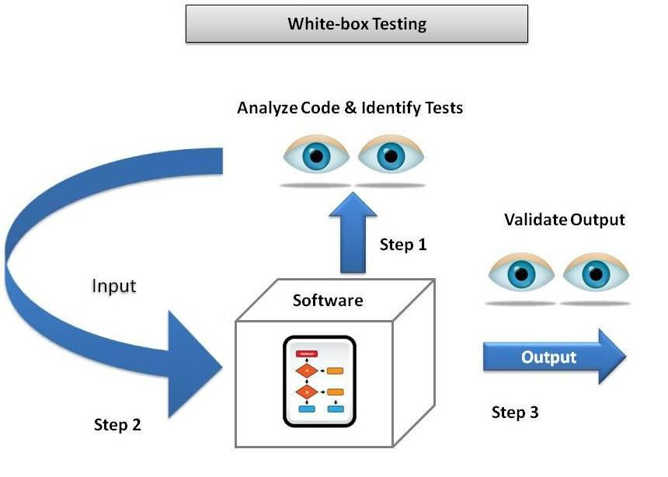I had tested Different types of Sorting Buttons available in my website. It works properly as well as all the facilities of our website like insertion of New Array, Stop Sorting, Size and Speed Adjustment button are also works properly.

After testing it is found that this project does not contain any bugs and are ready for farther process which is deployment.



Once testing is complete and the software is deemed ready for release, it is deployed or installed in the production environment. This may involve configuring servers, installing software packages, and ensuring that the system is operational and accessible to users.

The process of installing, configuring, and making software systems available for use in a specific environment or platform. Deployment may involve deploying software on local servers, cloud platforms, or mobile devices.



## The final phase of the Software Engineering involves ongoing maintenance and support of the software system. This includes addressing bugs and issues reported by users, accommodate changes in requirements, and improve performance or functionality, making enhancements or updates to the software, and ensuring its continued functionality and performance over time.



Sites Visited:

[www.google.com](http://www.google.com) [www. Youtube.com](http://www.youtube.com/)

[www.w3schools.com](http://www.w3schools.com)

https://en.wikipedia.org/wiki/Bubble_sort)

https://en.wikipedia.org/wiki/Selection_sort)

https://en.wikipedia.org/wiki/Insertion_sort)

https://en.wikipedia.org/wiki/Merge_sort)

https://en.wikipedia.org/wiki/Heapsort)

https://en.wikipedia.org/wiki/Quicksort)

Books Referred:

1. JavaScript Manuals.
2. CSS Manual
3. Learning web design 4th edition.





Developed By: Ajit Khanta